Document for Phase 1:

1. Statistical Data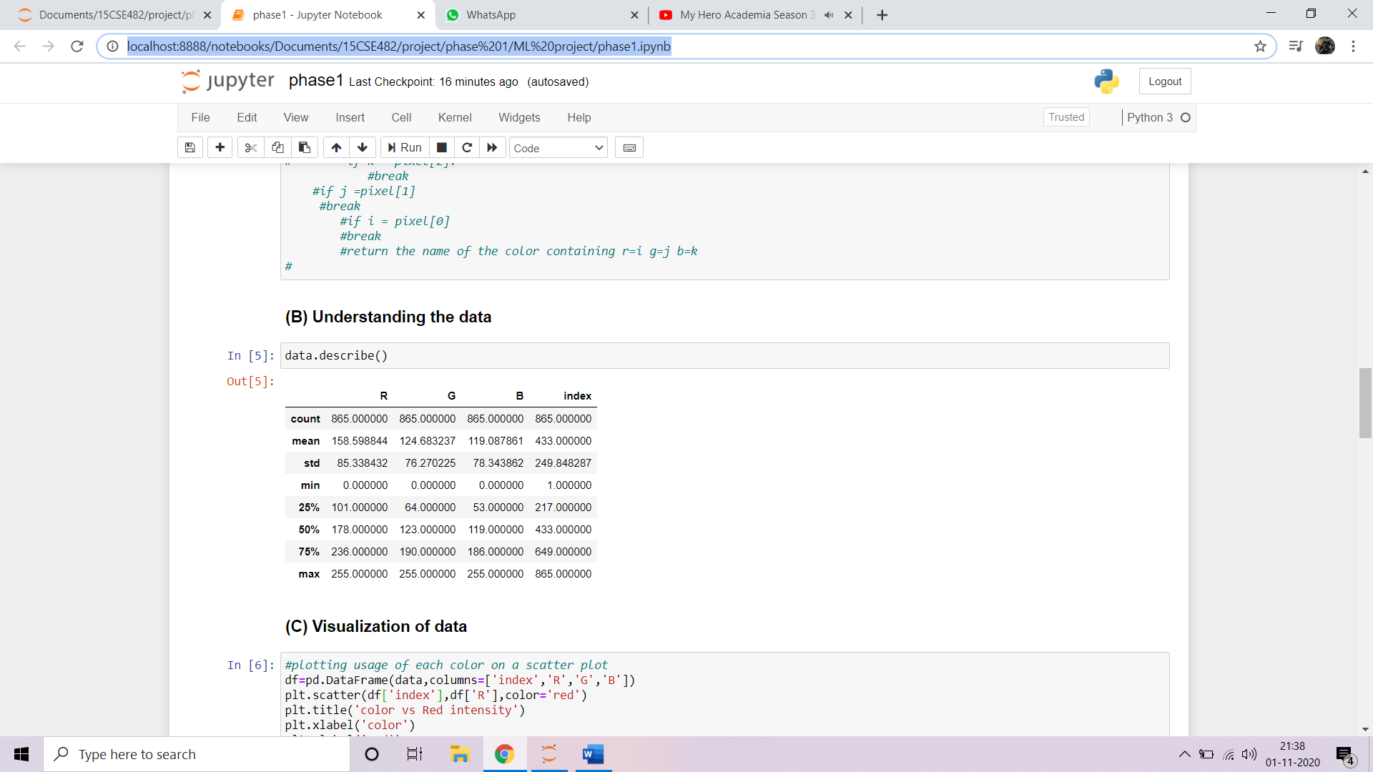

Observations:

* Min max of all colors is 0-255 and index is 1-865 because they range in those intervals
* At 25% mark red is highest intensity 101 and blue and green are close to 60
* Similarly other ranges have similar distribution.
* Mean for red is 158 which means in a general pixel red has slightly higher intensity followed by green and blue.
* Standard deviation is very similar but red edging out a little because of higher intensity as mentioned earlier.

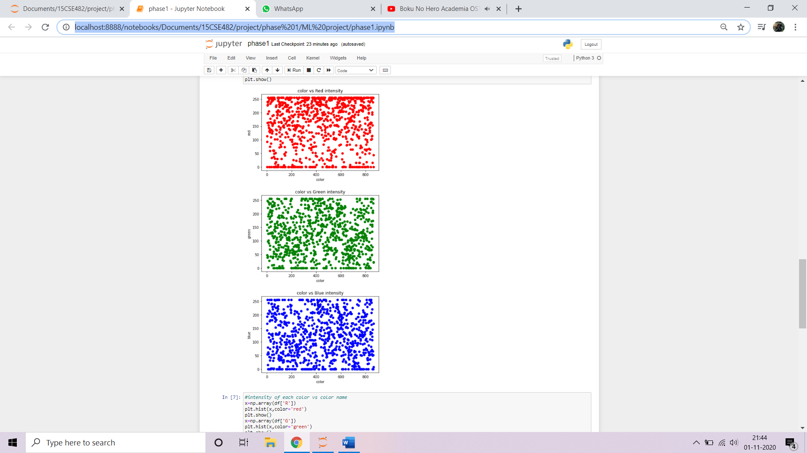

Scatter plot of intensity vs index for each colour

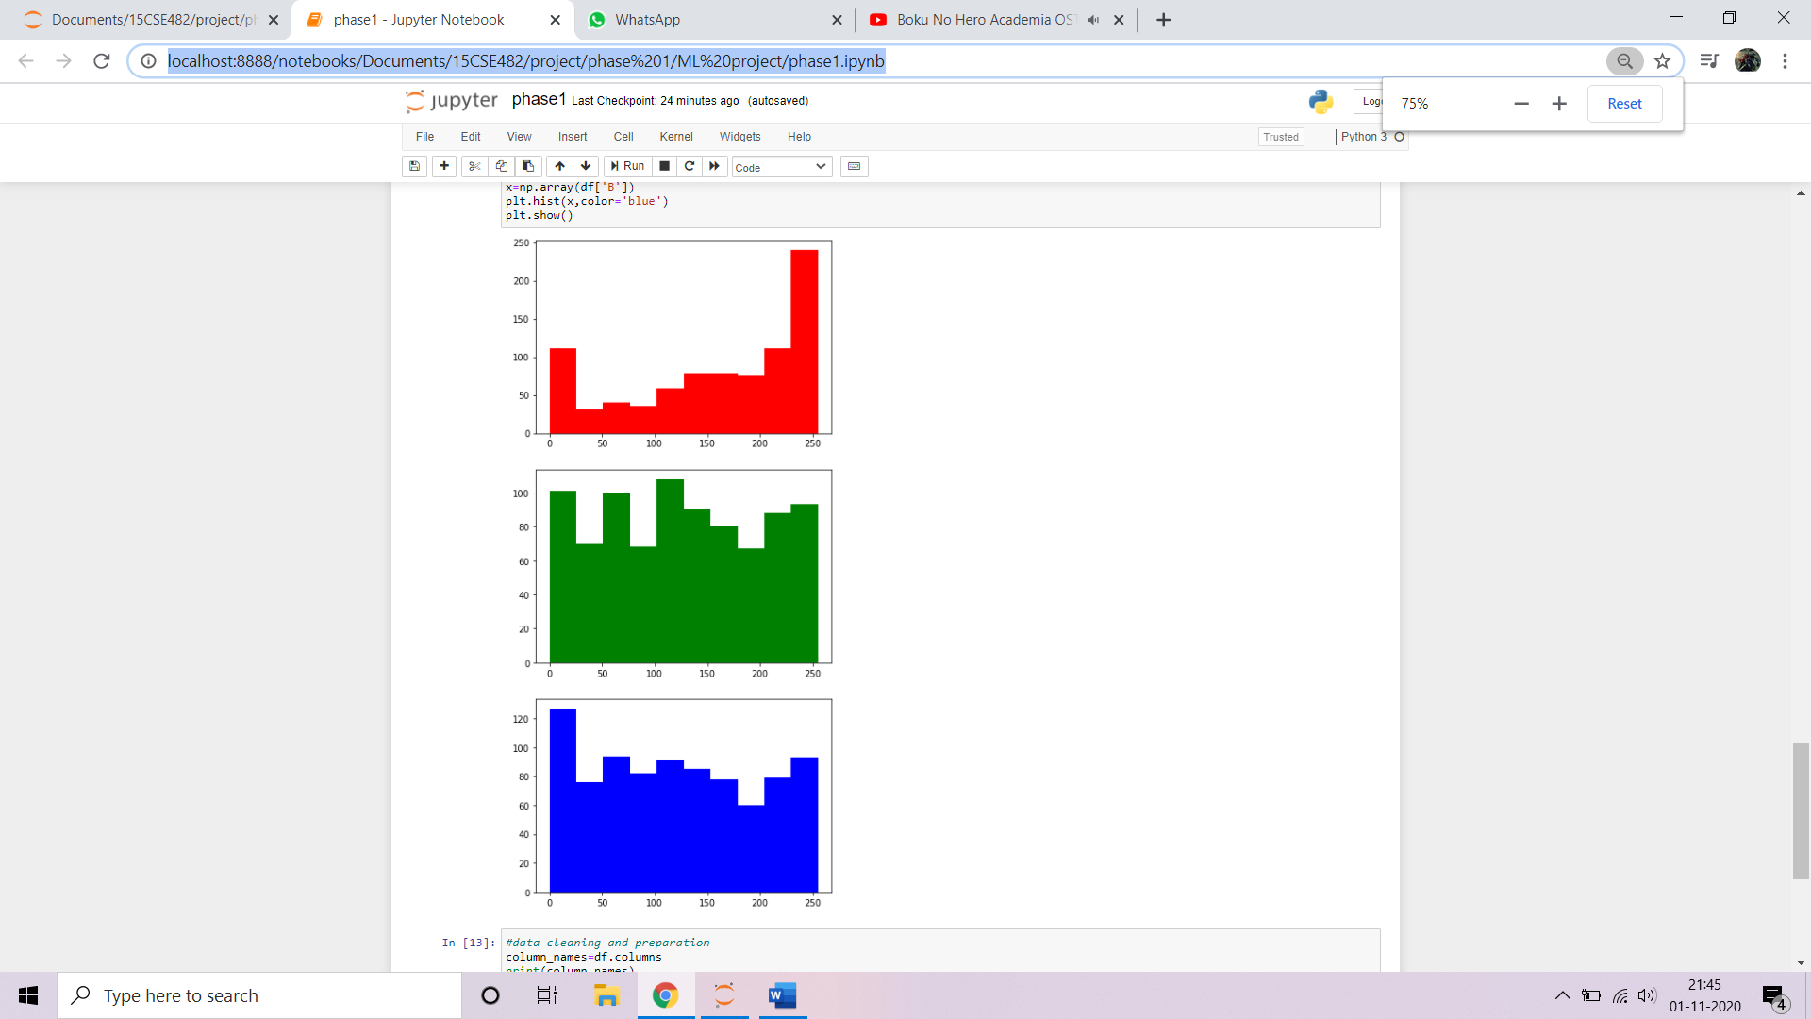

Histogram of usage of each colour